Name : Aditya Adinath Kirtane ,Roll No. 26, Division : D15C

Advance devops experiment No. 10

**Aim:** To perform Port, Service monitoring, and Windows/Linux server monitoring using Nagios.

**Theory**: Port and Service Monitoring Port and service monitoring in Nagios involves checking the availability and responsiveness of network services running on specific ports. This ensures that critical services (like HTTP, FTP, or SSH) are operational. Nagios uses plugins to ping the ports and verify whether services are up and responding as expected, allowing administrators to be alerted in case of outages.

**Windows/Linux Server Monitoring**

Windows/Linux server monitoring with Nagios entails tracking the performance and health of servers running these operating systems. It includes monitoring metrics such as CPU usage, memory consumption, disk space, and system logs. Nagios employs various plugins to gather data, enabling administrators to ensure optimal performance, identify potential issues, and maintain uptime across their server infrastructure.

Step 1: sudo systemctl status nagios

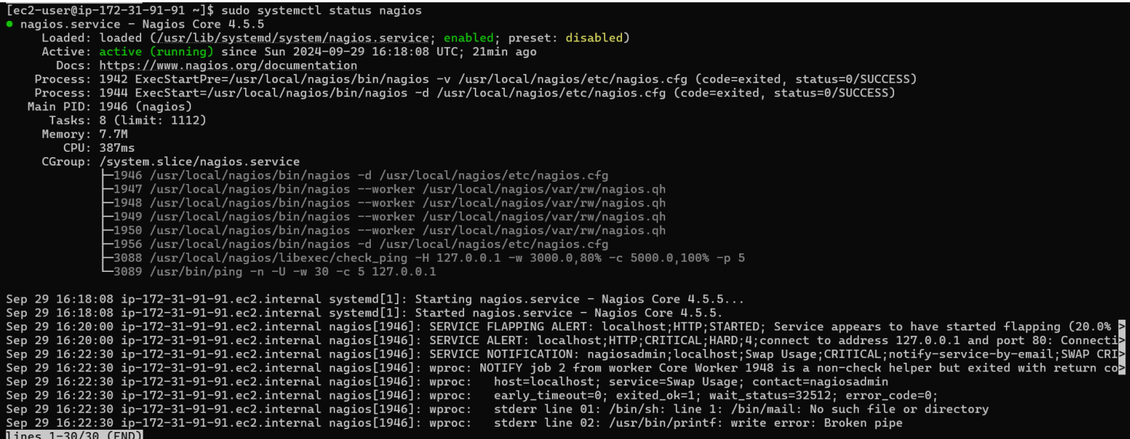

Step 2: Now create a new Ec2 instance.

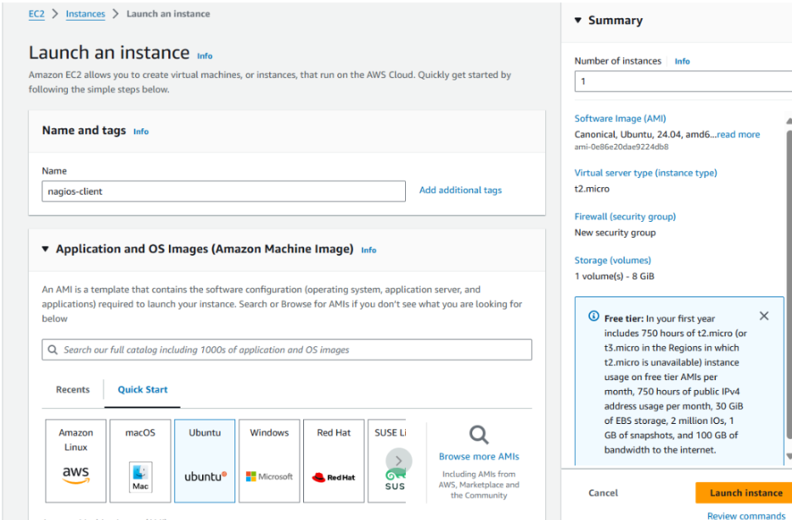

Step 3:Create a key pair.create a new instance type t2.micro.

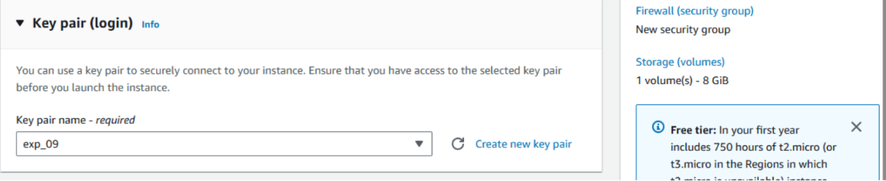

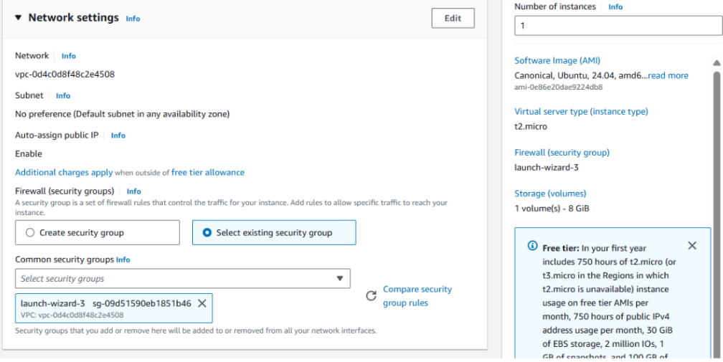

Step 3 : After connect Ec2 instance connect and then copy the command.

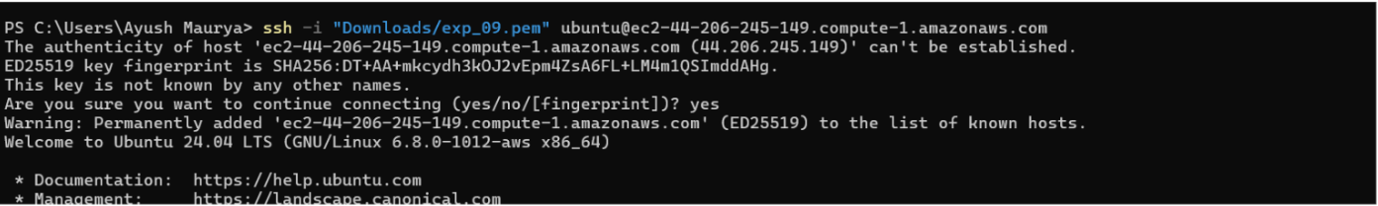

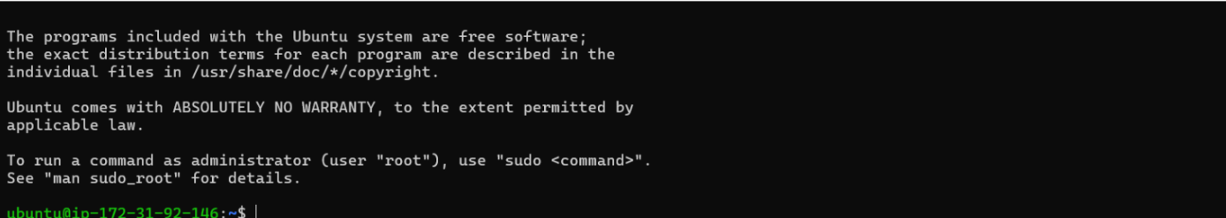

Now perform all the command on Nagios Host.

Ps -ef | grep nagios

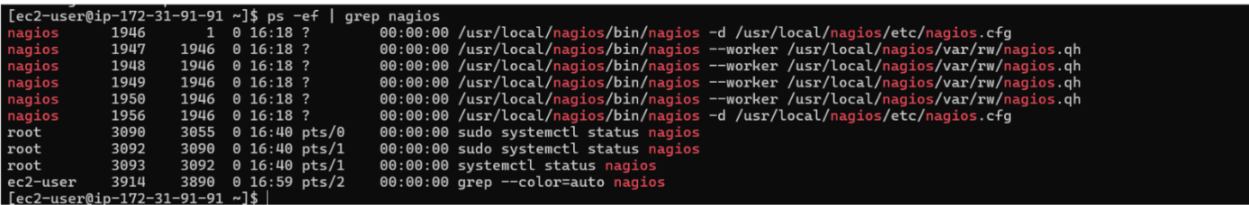

Sttep 5 : sudpo.su

mkdir/user local/nagios/etc/object/monitorhost



Step 6 : copy the sample linuxhost.cfg to localhost.cfg



Step 7 : open linux server.cfg using nano.

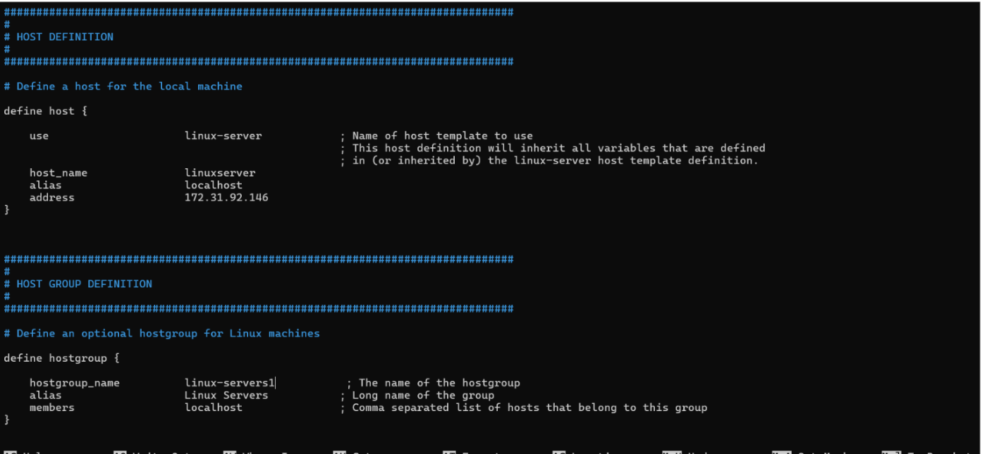

Step 8 : Update the file Nagios. Config file.

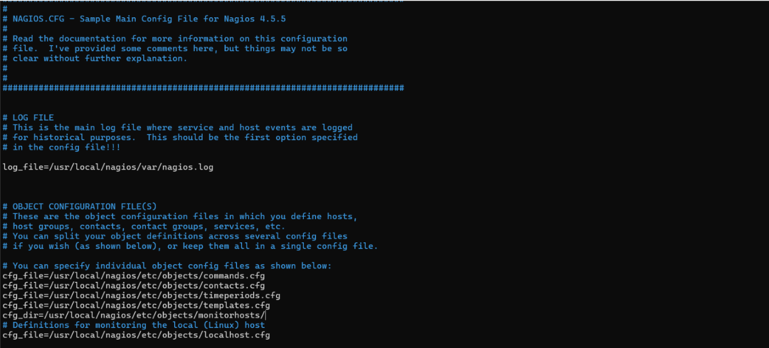

Step 8: Now verify configuration files

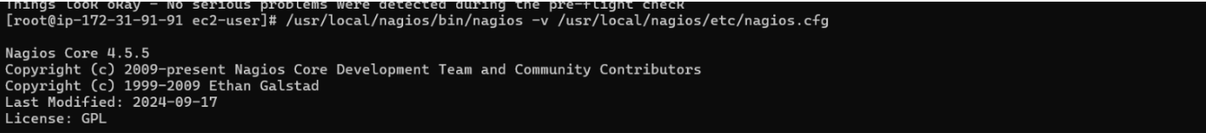

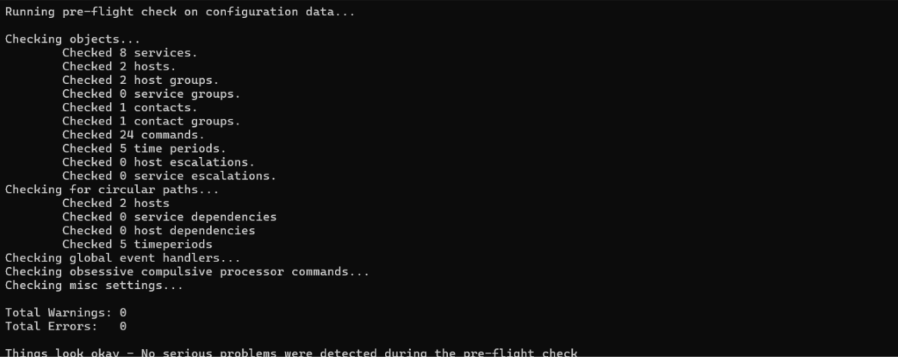

Step 10:service nagios restart.



Step 11: Now go to nagios client ssh terminal

Sudo apt update -y

Sudo apt install gcc -y

Sudo apt install -y